Testing Jmeter localhost n: 5000 c: 10

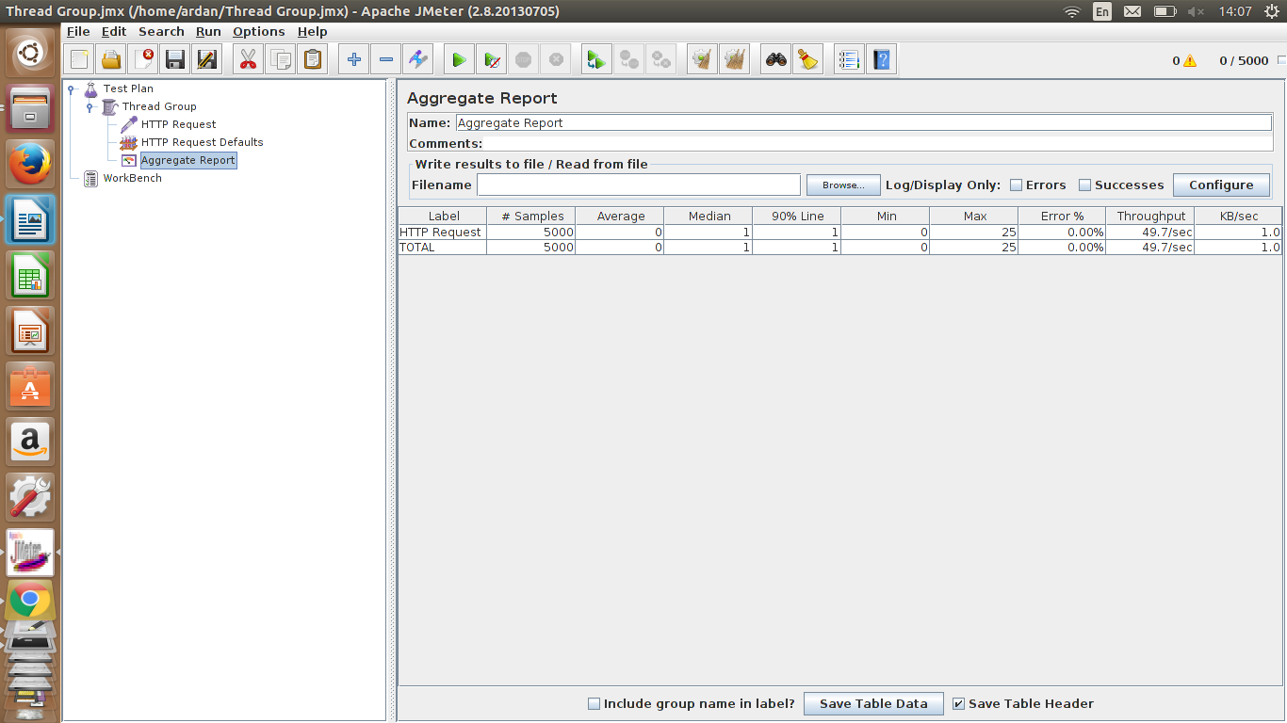

Testing Jmeter localhost n: 5000 c: 200

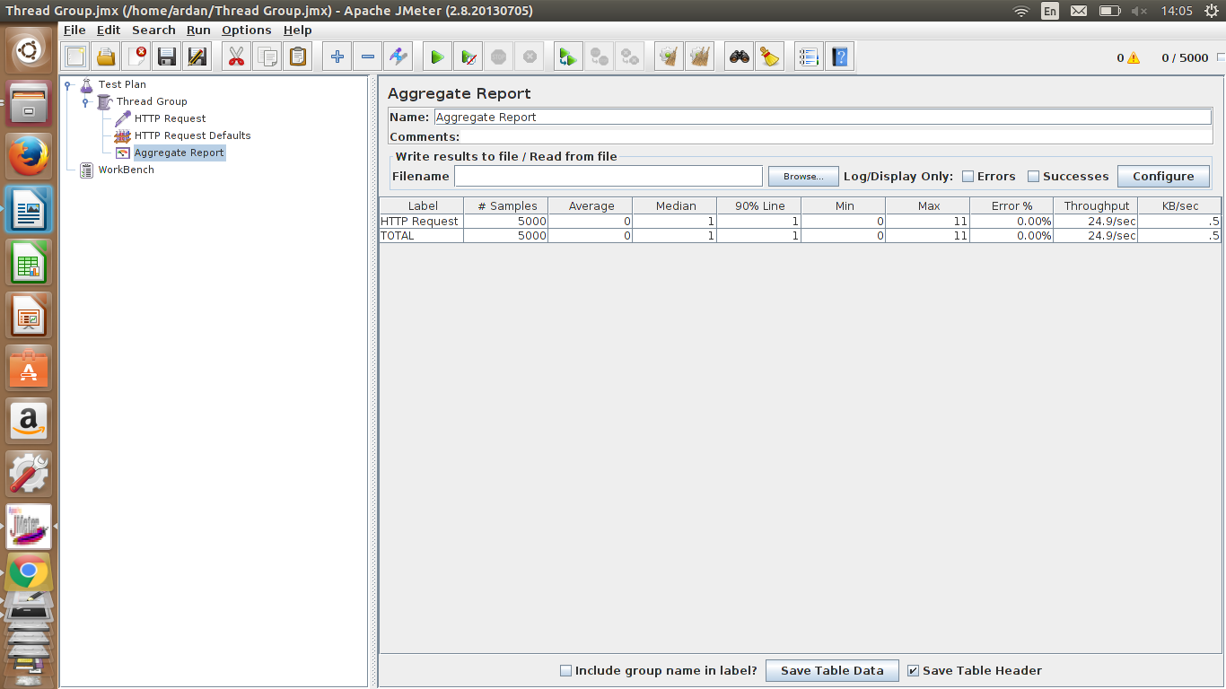

Testing Jmeter localhost n: 5000 c: 500

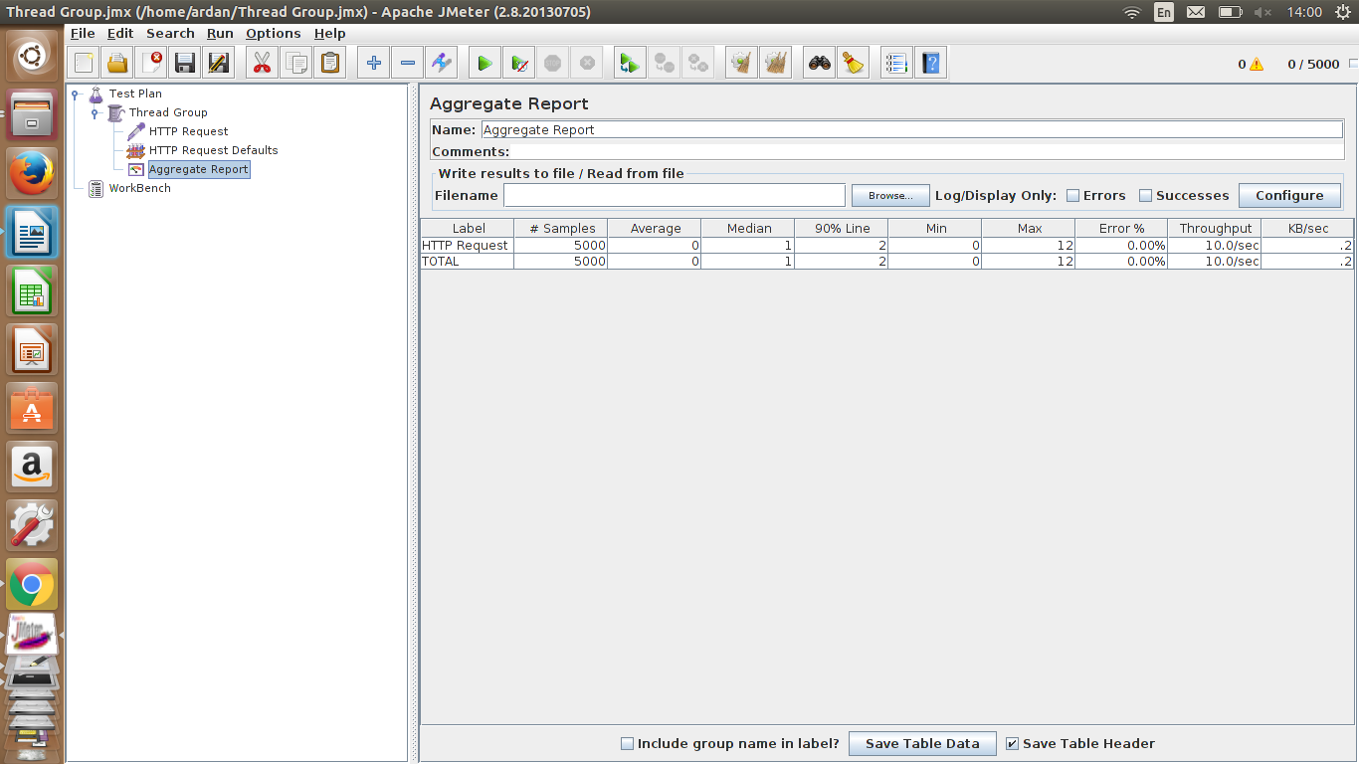

Testing Jmeter localhost n: 5000 c: 1000

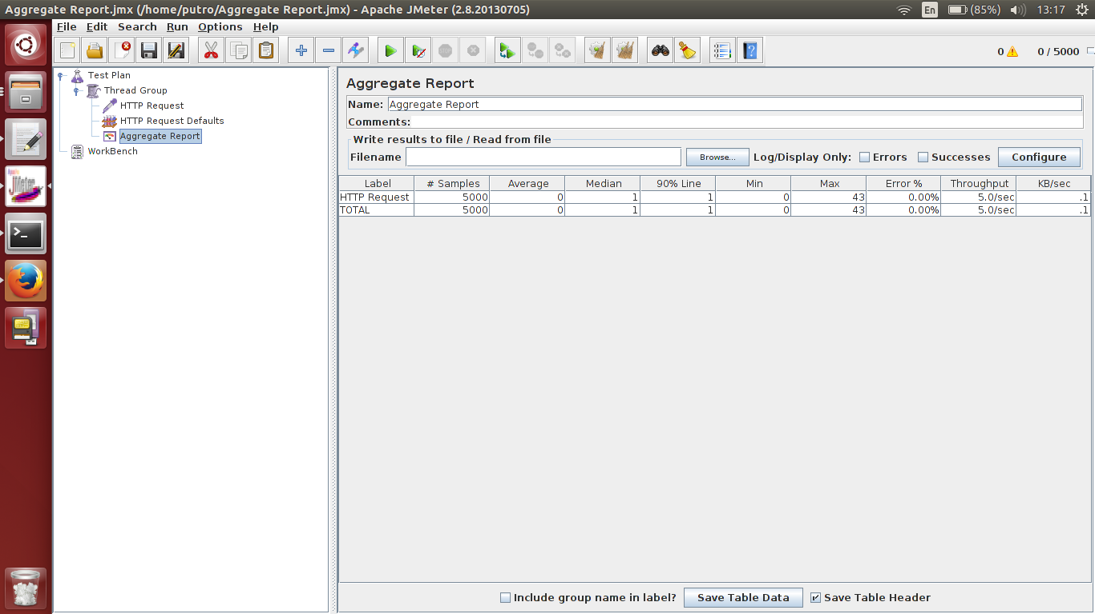

Testing Jmeter WIFI n: 5000 c: 100

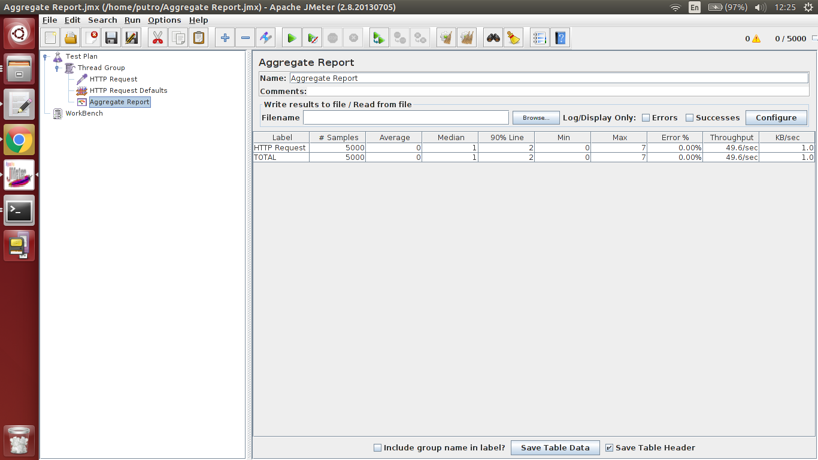

Testing Jmeter WIFI n: 5000 c: 200

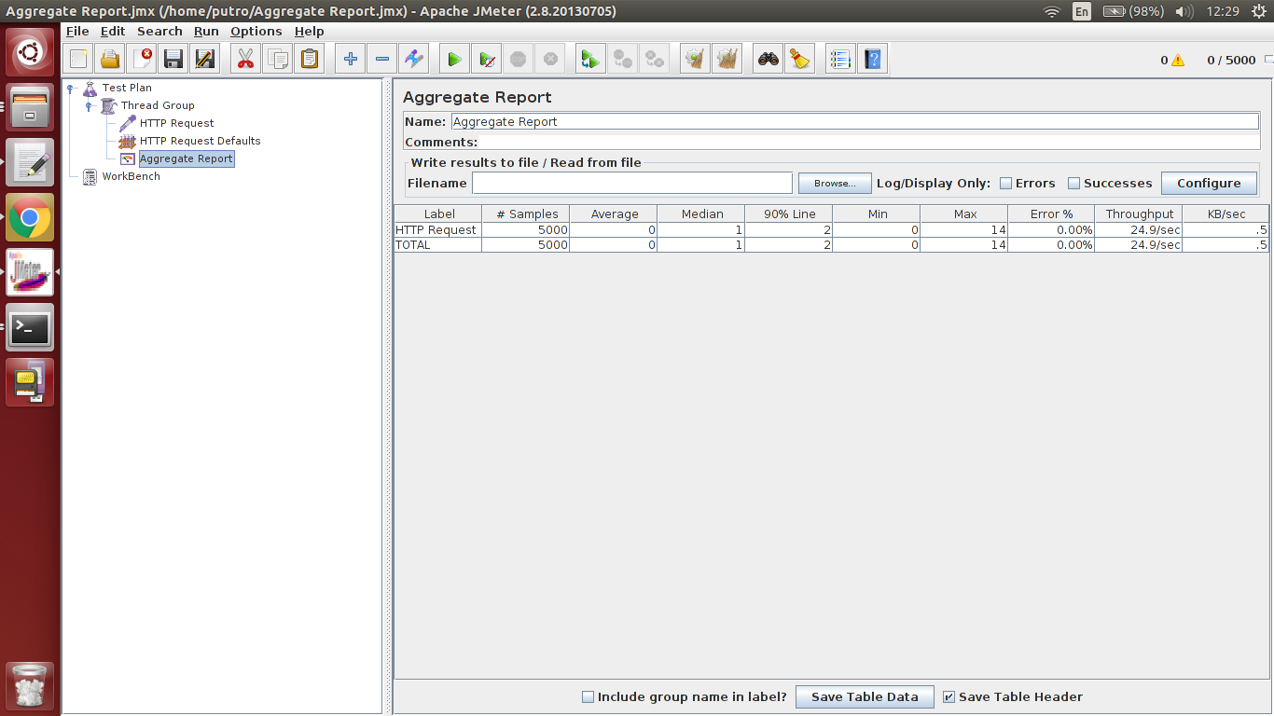

Testing Jmeter WIFI n: 5000 c: 500

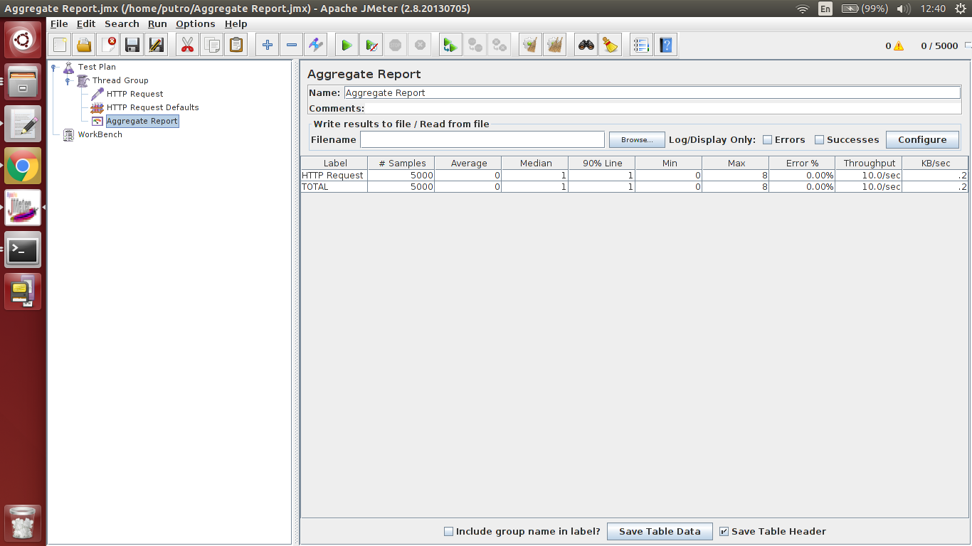

Testing Jmeter WIFI n: 5000 c: 1000

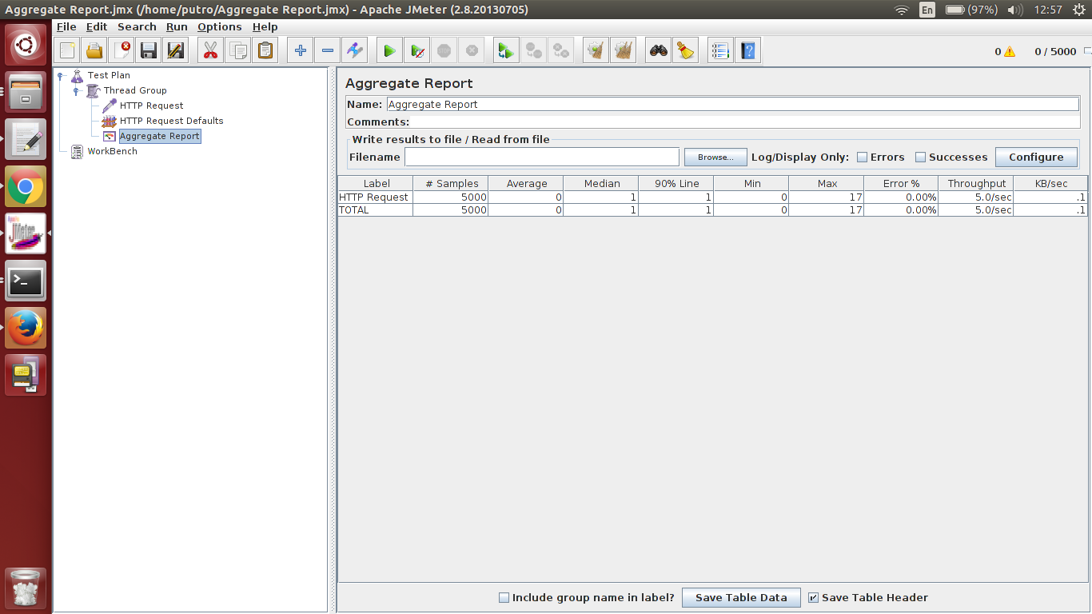

Testing Jmeter LAN n: 5000 c: 100

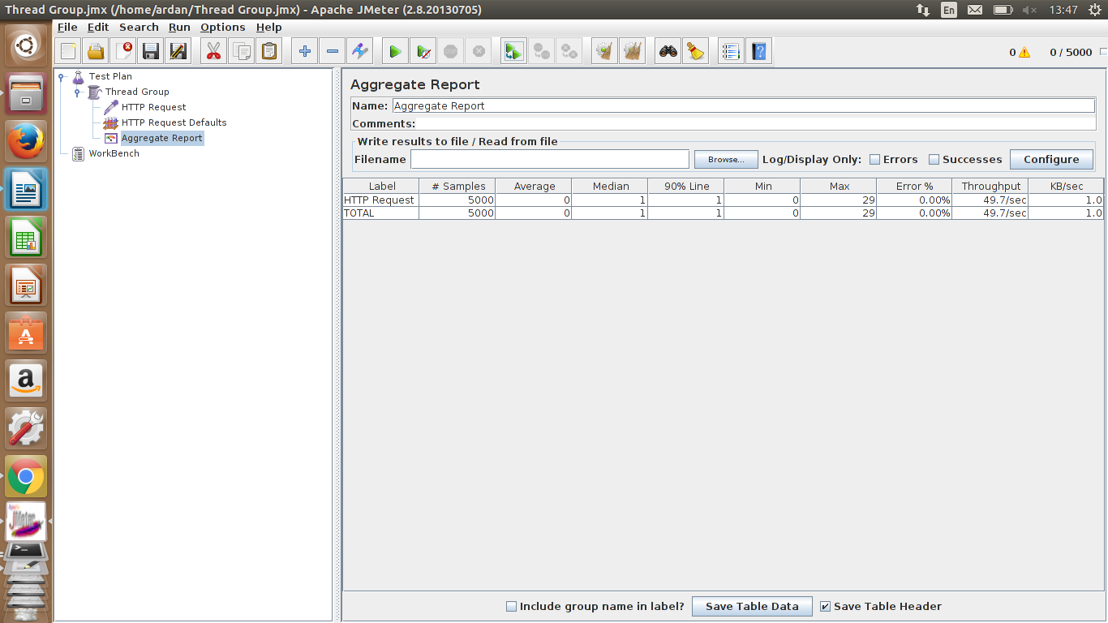

Testing Jmeter LAN n: 5000 c: 200

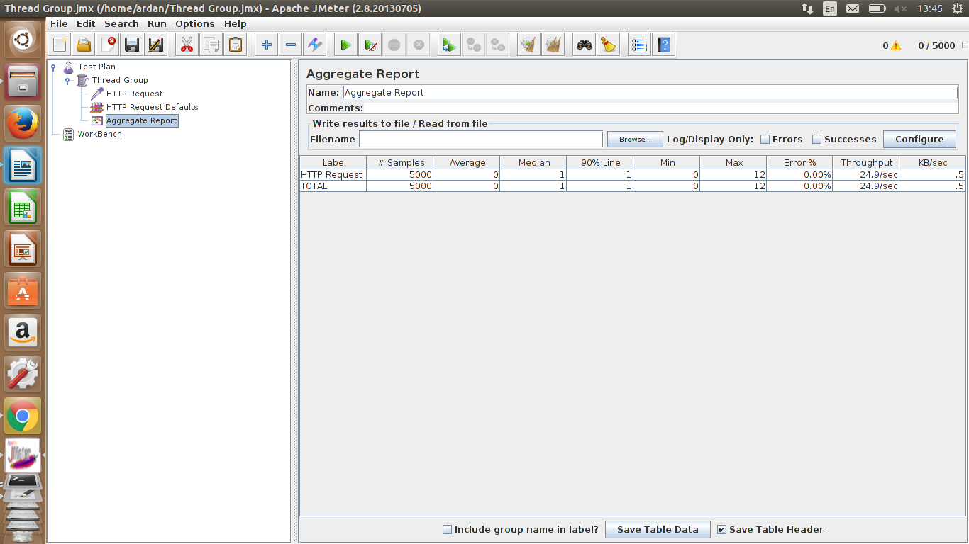

Testing Jmeter LAN n: 5000 c: 500

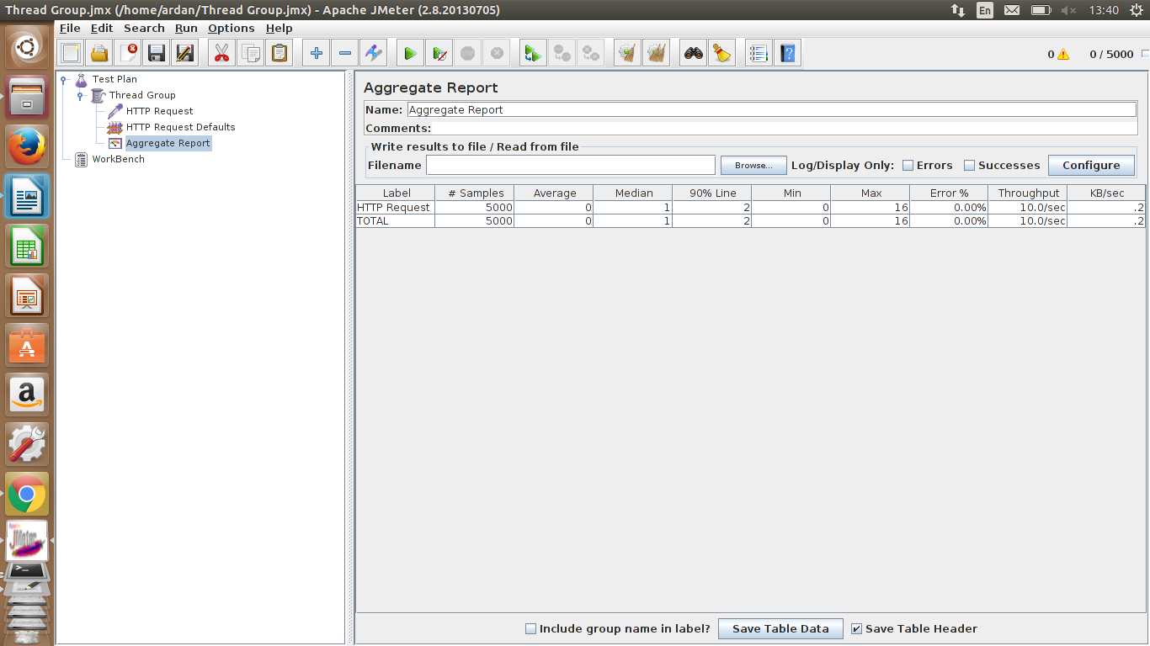

Testing Jmeter LAN n: 5000 c: 1000

